IT specialists and their job Market

Final Exam

420-CT1-AS C9_COMPUTER TOOLS_LEA3Q_ONLINE COURSE section 07442

Zohreh Moeini

Contents

JOB IN IT INDUSTRY 2

Front-end developer: 2

Back-end developer: 2

QA analyst: 3

References 3

# JOB IN IT INDUSTRY

## Front-end developer:

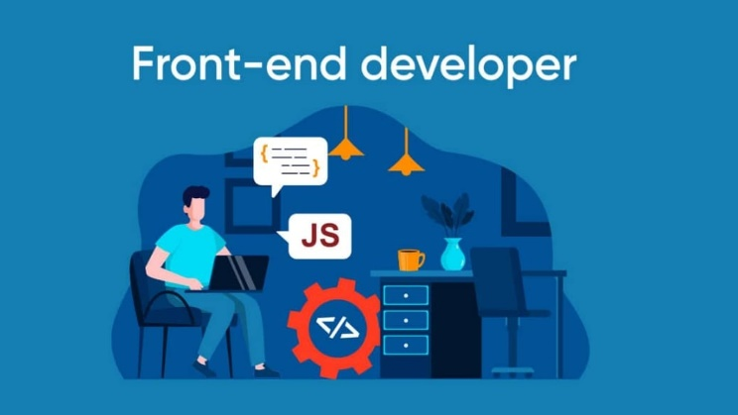

A Front-End Developer is a professional who uses JavaScript, CSS, or HTML to convert data to a graphical interface, thereby creating web applications and sites that render on the client-side. They work closely with Back End Web Developers to create software that users view and interact with, and perform various duties, including fixing bugs on sites, maintaining software workflow management, and implementing design for mobile sites. (indeed.com, n.d.)

## Back-end developer:



In our digital world, nearly every company has a website, or uses software and IT systems. Backend development helps these systems run. Backend developer responsibilities include creating, maintaining, testing, and debugging the entire back end of an application or system. This includes the core application logic, databases, data and application integration, API, and other processes taking place behind the scenes. A highly skilled back-end developer is a programmer who knows how to analyze user needs to ensure a positive user experience. (linkedin.com, n.d.)

## QA analyst:[1]



A QA analyst is the subject matter expert when it comes to pinpointing errors or defects within software and systems, and determining how those can be resolved. They operate hands-on, using the software or system themselves so that they have a firsthand experience. This is often done with software specifically designed for testing. (insightglobal.com, n.d.)

# References

indeed.com. (n.d.). *indeed.com*. Retrieved from indeed.com: https://ca.indeed.com/hire/job-description/front-end-developer?gclid=Cj0KCQiAm4WsBhCiARIsAEJIEzVJgr9BCK0JtgfY5NZ2ZPuJ8Zl6S2b9QF141Kv7VVe-7uNgFHI-Bb8aAs_oEALw_wcB&aceid=&gclsrc=aw.ds

insightglobal.com. (n.d.). *insightglobal.com*. Retrieved from insightglobal.com: https://insightglobal.com/blog/whats-a-qa-analyst/

linkedin.com. (n.d.). *linkedin.com*. Retrieved from linkedin.com: https://business.linkedin.com/talent-solutions/resources/how-to-hire-guides/back-end-developer/job-description

1. QA analyst reference footnote (just to let you know I know how to edit this part)